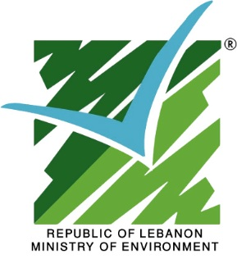 | 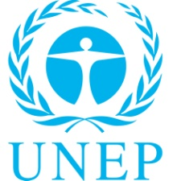 | 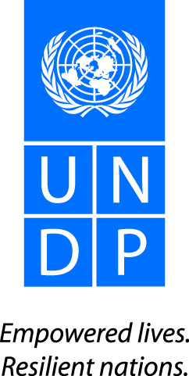 | 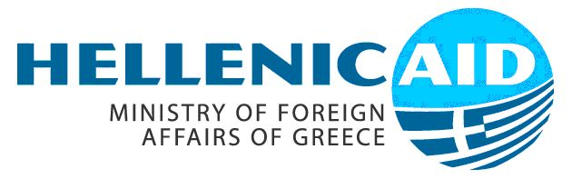

Arab and Mediterranean Regional Conference on Environmental Resources Monitoring and Management
Call for Papers
Introduction
Coastal resources are increasingly determining the wealth, welfare, and stability of coastal areas. New and innovative approaches are needed to manage coastal areas in order to overcome the conflicts that emerge when the interactions among natural, societal, and political forces are overlooked. At the heart of these conflicts are complex coastal networks. Solutions can only emerge if science and policy are blended to manage the coastal areas resources.
In 2011, UNEP and the Ministry of Environment in Lebanon, with the cooperation of UNDP-Lebanon, launched a project, funded by the Greek Aid, entitled Environmental Resources Monitoring in Lebanon. It consists of the development of a monitoring system for the coastal zone in Lebanon based on ecosystem approach, policy reforms in ICZM and land use and development of air pollution monitoring system.

Goal and Objective
The overall goal of the conference is to provide a science-policy interface to discuss the status and management of coastal areas at local and regional levels focusing on critical issues: monitoring and management of coastal and marine resources and air quality.
The aim of the Conference is to provide a forum to enhance the use of science, and to engage the scientific community in protecting environmental resources through knowledge synthesis and sharing.

Target Audiences
The conference targets scientists, experts, planners, and decision makers working on the science-policy interface to allow for a healthy exchange on critical issues related to coastal cities, and on ‘implementation science’ for policy development.
Expected Accomplishment
- Sharing and replication of the results of the project Environmental Resource Monitoring in Lebanon with regional scientists and policy stakeholders;
- Raising awareness of the importance of considering and dealing with the strong interaction between coastal and marine ecosystems and land-based activities, and identifying the major inter-relations, inter-dependencies, challenges, and opportunities today and in the future of the West Asia Region and the Mediterranean Region;
- Facilitating an open discussion platform to share knowledge and experiences between researchers, executives, decision and policy makers, and other stakeholders on modern methodologies and techniques used in the planning and preparation of medium- and long-term national strategies for the sustainable management of environmental resources (coastal and marine resources and air quality) in the West Asia Region;
- Enhanced understanding by the regional community regarding facilitating science – policy interaction and feedback on the status of coastal zones and their monitoring and management;
- Sharing ideas and knowledge through the scientific community and policy makers (including the experience of implementing coastal management best practices at all levels), as well as best approaches to governance and dealing with socio-economic issues jointly identified, including responding to emerging issues and recommend follow-up;
- Formulating a research framework and strategy for the required research in the field of identifying the role and value of coastal and marine ecosystems in the region;
- Building a network between individuals, institutes, NGOs in the region, the Arab countries, and other countries that are interested in scientific research in the conservation of coastal and marine ecosystems;
- Building a network between individuals, institutes, NGOs in the region, the Arab countries, and other countries that are interested in scientific research in air quality management and long-range trans-boundary air pollution;
- Enhanced practical understanding of ecosystem-based management (EBM) principles and approaches, including skills to select and collate key information required for the development and implementation of EBM relevant to the coastal and marine environment;
- Enhanced skills for design and application of EBM approaches and tools for integrated marine environment and resource management at national and regional levels;
- Enhanced skills in the design and application of air quality management techniques and integration of these techniques at a national and regional level;
- Increased integration between national and regional institutions in the protection of coastal and marine ecosystems and air quality;
- Enhanced networking between regional partners and players in efforts addressing adoption of ecosystem approach in coastal and marine environment planning and management;
- Understanding relevant international instruments to protect the coastal and marine environments and understanding the linkage between the different instruments.

Conference Themes
The conference is structured into key note speakers and scientific research with policy papers targeting the following topics:
- Application of Integrated Coastal Zone Management concept including economic zones: Land use, coastal planning, socio economic impacts and opportunities of land use, classification of sensitive areas, conservation of ecosystems and biodiversity using ecosystem based management, the blue carbon concept, coastal ecosystem vulnerability assessment, Ecosystem Based Management (EBM) and economic valuation of coastal ecosystem services, policy and legislative development for mainstreaming of sustainable management of marine and coastal areas.
- Monitoring of coastal water and marine environment: monitoring of marine biodiversity, monitoring of coastal waters, importance of maintaining a Pollutant Release and Transfer Register (PRTR), indicators, data handling and tools, nutrient modeling, total pollution loads, ecological coastal ecosystem vulnerability assessment, land-based activities affecting the marine environment, coastal areas, and the associated watersheds, namely the activity of touristic resorts, coastal geomorphology and coastal erosion.
- Coastal adaptation to climate change, Marine Protected Areas (MPAs), Ecosystem Based Adaptation (EBA), coastal vulnerability to climate change. Monitoring and management of air pollution in coastal areas: identification of hot spots, monitoring of pollutants, design of monitoring system, data management and modeling, emission studies, Mediterranean trans-boundary pollution, impacts of air pollution on health, on forests and vegetation, air pollution in urbanized settings and traffic management techniques, air pollution and climate change inter-linkages; policy development and impacts on improvement of air quality
- Private sector, NGOs and civil society involvement in resource conservation and management in coastal areas. Participatory approach in coastal management. Information and communication, regional initiative in coastal management.

Implementation and Logistics
Date and Venue
The conference will take place in Beirut –Lebanon in 15-16 May 2013. The venue will be communicated at later stage.
Language
The conference offers interpretations in English, French, and Arabic. Documentation and background materials will be available only in English.
Participants
The conference is open for scientists, policy and decision makers, planners, civil society from the Mediterranean (21 countries) and Arabic countries (24 countries).
A number of key note speakers, selected on the basis of their regional and global achievements, will be invited to present their specialties based on one of the three major topics of the conference. The conference will provide the opportunity to present papers by a limited number of policy makers and scientists on the results of their own activities.
The participation is free of charge. Limited funding is available to support a number of participants who will present papers.
Participants are requested to complete the attached registration form and send it to Ms. Dena Kassem before 28 February 2013.
Deadlines
- Abstracts should be sent to UNEP ROWA office in Bahrain by 28 February 2013.
- Authors will be notified of acceptance of abstract by 20 March, 2013, by fax or preferably by email address provided by authors.
- The deadline for full text submission is 15 April 2013.
Submission Format
Abstracts should not exceed 300 words and are sent along with a completed “registration form”. Abstracts should clearly state the objectives, methodology, results, and conclusions. Abstracts should be typed on an A4 white paper, single-spaced with double space between paragraphs, font 12 Calibri and 12 characters per inch.
Hotel Reservations
A wide range of hotels are available in Beirut –Lebanon. In due time, the organizers will provide you with a list of hotels located in close proximity to the event venue.

Visa entry to Lebanon
Participants are requested to contact the Embassy of Lebanon in their respective countries to obtain the necessary entry visa if need be.

Enquiries and Correspondences:
All enquiries and correspondences prior to the conference should be addressed to:
UNEP ROWA
Mr. Fouad Abousamra - Chairman of the Conference
Regional Coordinator
Ecosystem Management
UNEP, ROWA
P.O. Box 10880
Manama, Kingdom of Bahrain
Tel +97317812783
Fax +97317825111/10
Fouad.Abousamra@unep.org

Ms. Hiba Sadaka for general organization
UNEP ,ROWA
P.O. Box 10880
Manama, Kingdom of Bahrain
Tel +973 17812786
Fax +97317825111/10
Hiba.Sadaka@unep.org

Ms. Dena Kassem for papers-related issues
UNEP ,ROWA
P.O. Box 10880
Manama, Kingdom of Bahrain
Tel +97317812787
Fax +97317825111/10
Dena.kassem@unep.org

Ms. Manal Al Abed for participants’-related issues
UNEP, ROWA
P.O. Box 10880
Manama, Kingdom of Bahrain
Tel +973 17812766
Fax +97317825111/10
Manal.Aabed@unep.org

Lebanon
-------------------------------------------------------------------------------------------------------------------------------

Ms. Nour Masri for general organization in Lebanon
Project Manager, UNDP - Lebanon
Ministry of Environment - Lazarieh Bldg
Floor 8 - Room 8-21, Riad El Solh, Lebanon
P.O. Box 11-2727
T/F: +961 (0) 1 976555 # 445
nour.masri@undp-lebprojects.org

Arab and Mediterranean Regional Conference on Environmental Resources Monitoring and Management
15 and 16 May 2013
Beirut-Lebanon
Registration Form
Full Name
Last Name
Address
Street: |  | Number:
P.O. Box: |  | City:
Postal Code: |  | Country:
Telephone: |  | Passport Number:
Fax: |  | Issuing date and place:
Email: |  | Expiry date:
Paper information
Would you like to present a paper |  | Yes No
Title | _____________________________________________________  _______________________________________
Authors | _____________________________________________________  _______________________________________

